

COURSE: | COAL
LAB: | 6
NAME: | MUZAMMIL BIN SOHAIL
ROLL NO.: | 22F - 3110
DEGREE: | BS - AI
SECTION: | 4A1

Question 1:
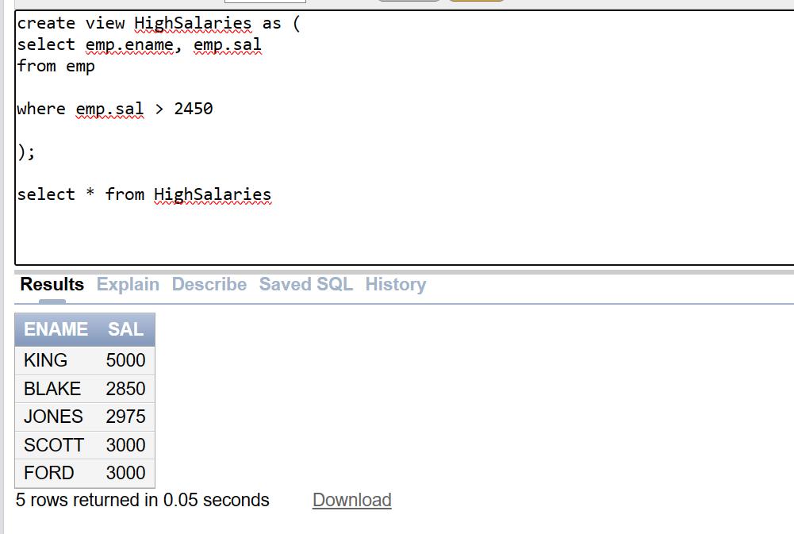
Question 2:
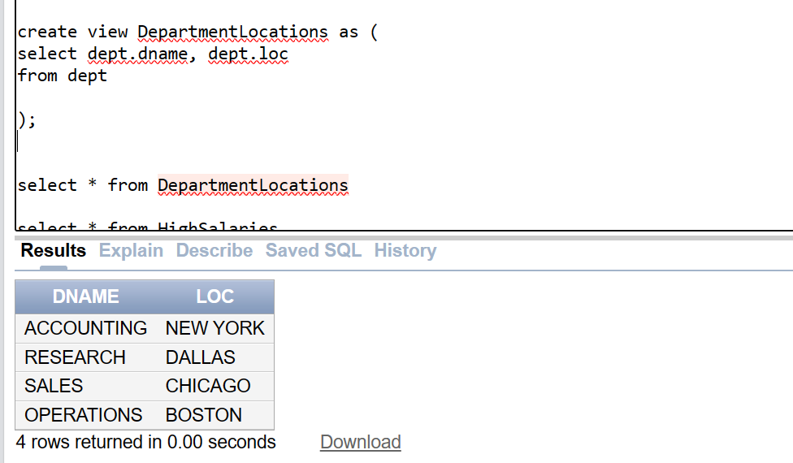
Question 3:
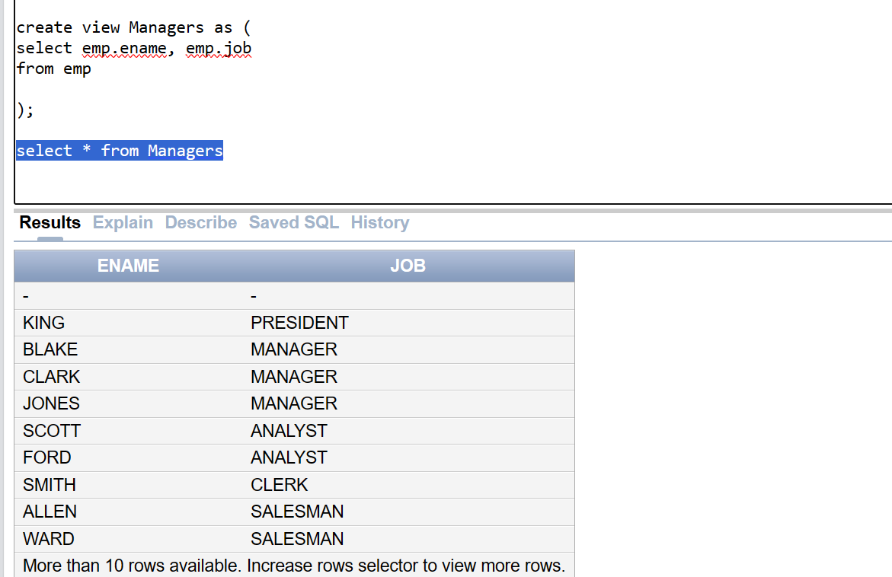

Question 4:
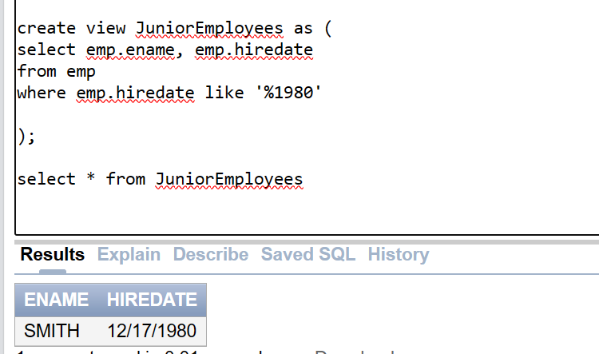
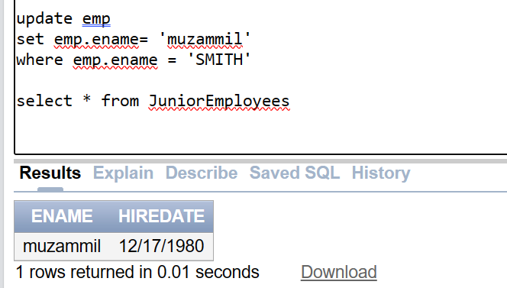
Question 5:
